**Lab Manual 1**

**NETWORK ESSENTIALS LAB Manual**

**User mode** : Basic Ping , Basic Trace , Basic show commands .

**Privilege Mode** : If you want to do complete monitoring , Complete show commands then PM .

100 per commands only show .

**Global Configuration mode** : Any changes then Global config mode .

**Basic configuration – Hostname, Clock, no ip domain lookup. Setting up History size**

R1(config)#hostname R1

R1#clock set 10:10:10 march 10 2020

R1(config)#no ip domain-lookup

R1#terminal history size ?

<0-256> Size of history buffer

**Configure login banner**

R1(config)#banner motd $ ALERT - HEADOFFICE ROUTE$

**Configure Password(Enable,Console,Telnet)**

R1(config)#enable password cisco

**Encrypt password**

R1(config)#service password-encryption

R1(config)#enable secret cisco123

**Save all configurations** .

R1#copy running-config startup-config

Destination filename [startup-config]?

Building configuration...

[OK]

**Remove all configurations**

Router#**erase startup-config**

**Restart Router and switch**

Router#**reload**

R1(config)#line con 0

R1(config-line)#password cisco

R1(config-line)#login

R1(config-line)#exi

**TELNET – Pre requisites**

1.Connectivity

2.Enable password

Then configure telnet with below commands

R1(config)#line vty 0

R1(config-line)#password cisco

R1(config-line)#login

R1(config-line)#exi

R1(config)#username AAA password AAA

R1(config)#line vty 0 4

R1(config-line)#login local

R1(config-line)#exi

**Password recovery** – for routers

Physical OFF and ON

CTR+SHIFT+PAUSE/BREAK (Pause/Break or equivalent command depends upon diff laptops)

Self decompressing the image : #################################

monitor: command "boot" aborted due to user interruptp

rommon 1 > confreg 2142

rommon 2 > reset

Continue with configuration dialog? [yes/no]:no

Router>enab

Router#conf t

Router(config)#no enable password

Router(config)#no enable secret

Router#show version

Configuration register is 0x2142

Router(config)#config-register 2102

Router#reload

This time it will not ask for the password.

**How to assign IP address to the interface of the Router**

R1(config)#interface fastEthernet 0/0

R1(config-if)#ip address 10.0.0.1 255.0.0.0

R1(config-if)#no shutdown

R1(config-if)#exi

**Static routing**

Default commands for Topology .

R1 , R2 , R3 -

R1

Conf ter

interface fastEthernet 0/0

no sh

ip address 10.0.0.10 255.0.0.0

exi

hostname R1

interface serial 2/0

ip address 20.0.0.1 255.0.0.0

no sh

exi

R2

Conf ter

hostname R2

interface serial 2/0

no sh

ip address 20.0.0.2 255.0.0.0

no sh

exi

interface serial 3/0

ip address 30.0.0.2 255.0.0.0

no sh

exi

interface fastEthernet 0/0

ip address 50.0.0.10 255.0.0.0

no sh

exi

R3

Conf ter

hostname R3

interface serial 2/0

ip address 30.0.0.3 255.0.0.0

no sh

exi

interface fastEthernet 0/0

no sh

ip address 40.0.0.10 255.0.0.0

no sh

exi

do sh his

**R1**

Ip route 30.0.0.0 255.0.0.0 20.0.0.2

Ip route 40.0.0.0 255.0.0.0 20.0.0.2

Ip route 50.0.0.0 255.0.0.0 20.0.0.2

**R2**

Ip route 10.0.0.0 255.0.0.0 20.0.0.1

Ip route 40.0.0.0 255.0.0.0 30.0.0.3

**R3**

Ip route 10.0.0.0 255.0.0.0 30.0.0.2

Ip route 20.0.0.0 255.0.0.0 30.0.0.2

Ip route 50.0.0.0 255.0.0.0 30.0.0.2

**DEFAULT ROUTING**

R1

Ip route 0.0.0.0 0.0.0.0 20.0.0.2

**R2**

Ip route 10.0.0.0 255.0.0.0 20.0.0.1

Ip route 40.0.0.0 255.0.0.0 30.0.0.3

**R3**

Ip route 0.0.0.0 0.0.0.0 30.0.0.2

**SSH**

SSH, also known as Secure Shell or Secure Socket Shell, is a network protocol that gives users, particularly system administrators, a secure way to access a computer over an unsecured network.

**The default port for SSH client connections is 22 , Telnet 23**

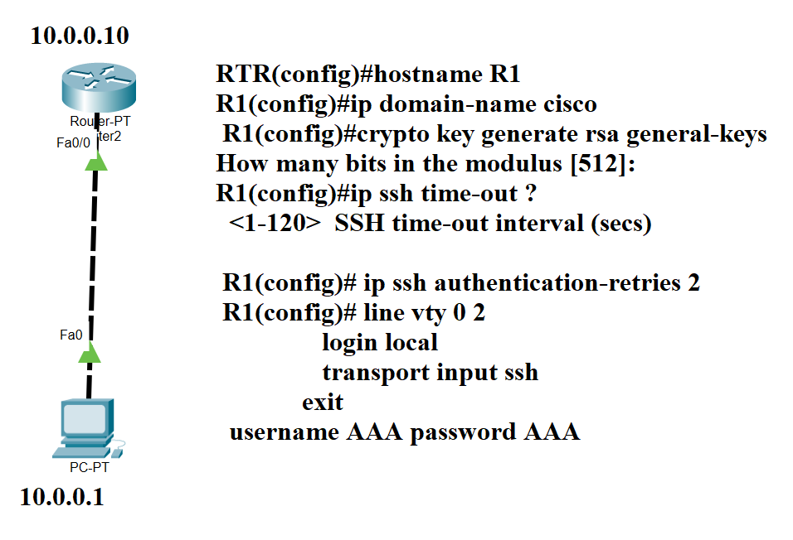

**SSH –l AAA 10.0.0.10**

**RIP V1 and V2**

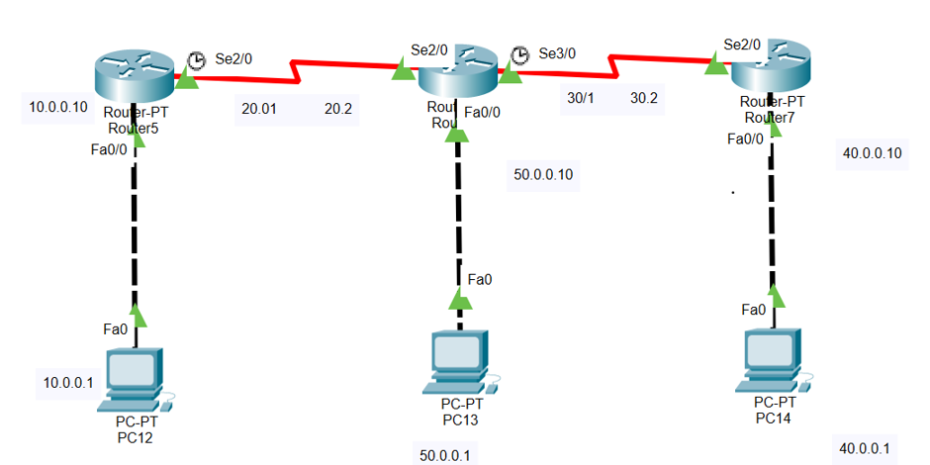

Default commands for Topology .

R1 , R2 , R3 -

R1

Conf ter

interface fastEthernet 0/0

no sh

ip address 10.0.0.10 255.0.0.0

exi

hostname R1

interface serial 2/0

ip address 20.0.0.1 255.0.0.0

no sh

exi

R2

Conf ter

hostname R2

interface serial 2/0

no sh

ip address 20.0.0.2 255.0.0.0

no sh

exi

interface serial 3/0

ip address 30.0.0.2 255.0.0.0

no sh

exi

interface fastEthernet 0/0

ip address 50.0.0.10 255.0.0.0

no sh

exi

R3

Conf ter

hostname R3

interface serial 2/0

ip address 30.0.0.3 255.0.0.0

no sh

exi

interface fastEthernet 0/0

no sh

ip address 40.0.0.10 255.0.0.0

no sh

exi

R1

router rip

version 2

network 10.0.0.0

network 20.0.0.0

no auto-summary

exit

R2

router rip

version 2

network 20.0.0.0

network 30.0.0.0

network 50.0.0.0

no auto-summary

exit

R13

router rip

version 2

network 30.0.0.0

network 40.0.0.0

no auto-summary

exit

**EIGRP**

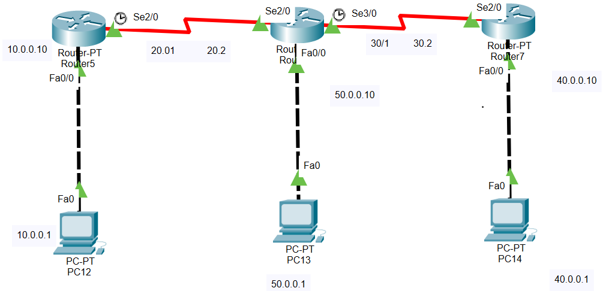

Default commands for Topology .

R1 , R2 , R3 -

R1

Conf ter

interface fastEthernet 0/0

no sh

ip address 10.0.0.10 255.0.0.0

exi

hostname R1

interface serial 2/0

ip address 20.0.0.1 255.0.0.0

no sh

exi

R2

Conf ter

hostname R2

interface serial 2/0

no sh

ip address 20.0.0.2 255.0.0.0

no sh

exi

interface serial 3/0

ip address 30.0.0.2 255.0.0.0

no sh

exi

interface fastEthernet 0/0

ip address 50.0.0.10 255.0.0.0

no sh

exi

R3

Conf ter

hostname R3

interface serial 2/0

ip address 30.0.0.3 255.0.0.0

no sh

exi

interface fastEthernet 0/0

no sh

ip address 40.0.0.10 255.0.0.0

no sh

exi

**R1**

router eigrp 100

network 20.0.0.0 0.255.255.255

network 10.0.0.0 0.255.255.255

No auto

exi

**R2**

router eigrp 100

network 20.0.0.0 0.255.255.255

network 30.0.0.0 0.255.255.255

network 40.0.0.0 0.255.255.255

No auto

exi

**R3**

router eigrp 100

network 30.0.0.0 0.255.255.255

network 40.0.0.0 0.255.255.255

NO auto

exi

**No auto summary – LAB EIGRP**

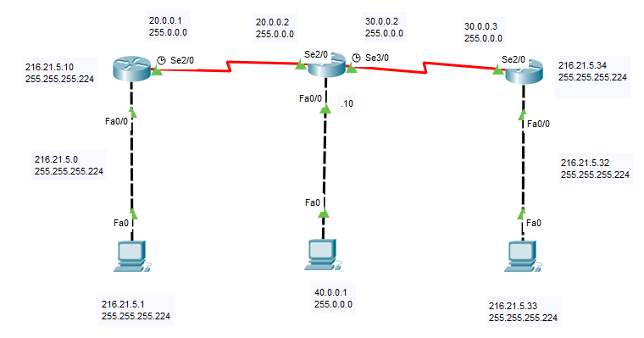

216.21.5.0 – 5 networks.

R1

hostname R1

interface fastEthernet 0/0

ip address 216.21.5.10 255.255.255.224

no sh

exi

interface serial 2/0

ip address 20.0.0.1 255.0.0.0

no sh

exi

router eigrp 100

network 20.0.0.0

network 216.21.5.0 0.0.0.31

exi

R2

hostname R2

interface fastEthernet 0/0

ip address 40.0.0.10 255.0.0.0

no sh

exi

interface serial 2/0

ip address 20.0.0.2 255.0.0.0

no sh

exi

interface serial 3/0

no sh

ip address 30.0.0.2 255.0.0.0

no sh

exi

router eigrp 100

network 20.0.0.0 0.255.255.255

network 30.0.0.0 0.255.255.255

network 40.0.0.0 0.255.255.255

exi

R3

interface fastEthernet 0/0

ip address 216.21.5.34 255.255.255.224

no sh

exi

interface serial 2/0

ip address 30.0.0.3 255.0.0.0

no sh

exi

router eigrp 100

network 30.0.0.0 0.255.255.255

network 216.21.5.32 0.0.0.31

exi

**OSPF LAB**

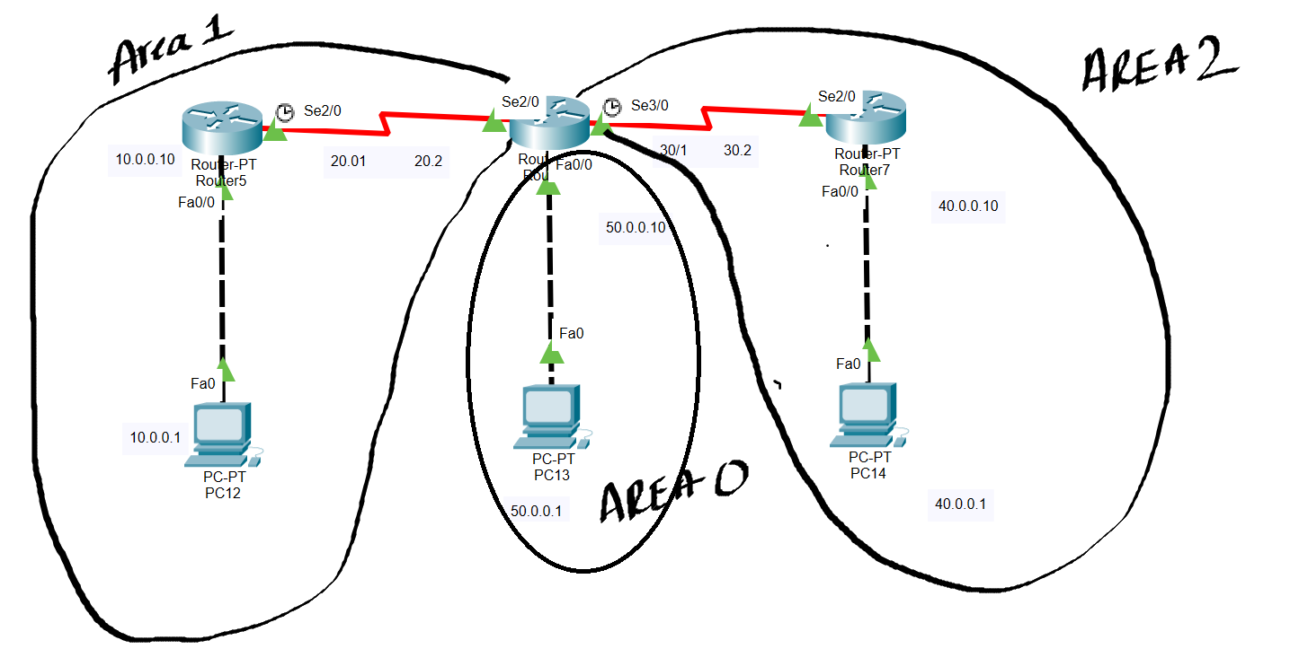

R1

router ospf 10

network 10.0.0.0 0.255.255.255 area 1

network 20.0.0.0 0.255.255.255 area 1

Exit

R2

router ospf 10

network 20.0.0.0 0.255.255.255 area 1

network 30.0.0.0 0.255.255.255 area 2

network 50.0.0.0 0.255.255.255 area 0

Exit

R3

router ospf 10

network 30.0.0.0 0.255.255.255 area 2

network 40.0.0.0 0.255.255.255 area 2

Exit

**DR and BDR LAB**

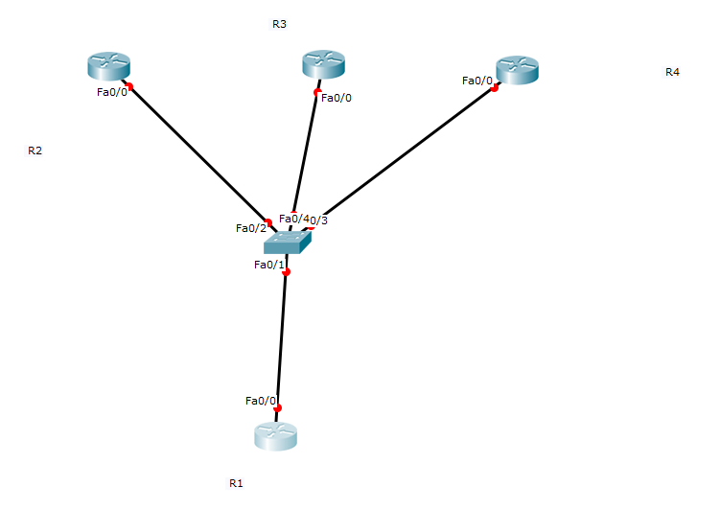

hostname R1

interface fastEthernet 0/0

no shutdown

ip address 10.0.0.1 255.0.0.0

exi

hostname R2

interface fastEthernet 0/0

ip address 10.0.0.2 255.0.0.0

no sh

exi

hostname R3

interface fastEthernet 0/0

no shutdown

ip address 10.0.0.3 255.0.0.0

exi

hostname R4

interface fastEthernet 0/0

ip address 10.0.0.4 255.0.0.0

no sh

exi

**router ospf 10**

**network 10.0.0.0 0.255.255.255 area 0**

**end**

**In all routers**

Show ip ospf Neighbours

R1(config)#**interface fastEthernet 0/0**

R1(config-if)#**ip ospf priority 200**

You change the priority if you like by using the **ip ospf priority** command:

* The default priority is 1.
* A priority of 0 means you will never be elected as DR or BDR.

You need to use **clear ip ospf process** before this change takes effect.

we need to reset the OSPF neighbor adjacencies so that we’ll elect the new DR and BDR.

#**clear ip ospf process**

**Reset ALL OSPF processes? [no]: yes**

#**clear ip ospf process**

**Reset ALL OSPF processes? [no]: yes**

I’ll reset all the OPSF neighbor adjacencies.

**R1#show ip ospf interface fastEthernet 0/0**

**Acl**

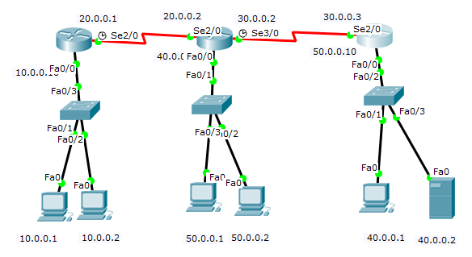

**TASK**

1. Deny host 10.0.0.1 from communicating with 50.0.0.0 – Numbered and named both.
2. Deny host 50.0.0.2 from communicating with 50.0.0.0

hostname R1

interface fastEthernet 0/0

ip address 10.0.0.10 255.0.0.0

no shutdown

exi

interface serial 2/0

ip address 20.0.0.1 255.0.0.0

no shutdown

exi

router eigrp 100

network 10.0.0.0

network 20.0.0.0

no auto-summary

exi

hostname R2

interface fastEthernet 0/0

ip address 50.0.0.10 255.0.0.0

no sh

exi

interface serial 2/0

ip address 20.0.0.02 255.0.0.0

no sh

exi

interface serial 3/0

ip address 30.0.0.2 255.0.0.0

no sh

exi

router eigrp 100

network 20.0.0.0

network 30.0.0.0

network 50.0.0.0

no auto-summary

exi

hostname R3

interface fastEthernet 0/0

ip address 40.0.0.10 255.0.0.0

no sh

exi

interface serial 2/0

ip address 30.0.0.3 255.0.0.0

no sh

exi

router eigrp 100

no auto-summary

network 30.0.0.0

network 40.0.0.0

exi

**R2 - Numbered**

conf t

access-list 10 deny 10.0.0.1

access-list 10 deny 50.0.0.2

access-list 10 permit any

interface fastEthernet 0/0

ip access-group 10 out

exi

After configuring remove seq number 20 by giving “no access-list 10 deny 40.0.0.2”

**R2-Named** – Without permit any.

**ip access-list standard cisco**

**deny host 10.0.0.1**

**deny host 50.0.0.2**

**exi**

**interface fastEthernet 0/0**

**ip access-group cisco out**

**exi**

After configuring remove seq number 20 by giving “no deny host 40.0.0.2”

**Task**

1. **Deny the user 10.0.0.1 should not access 40.0.0.2 http service**
2. **Deny the user 10.0.0.2 should not be able to use ICMP to 40.0.0.2 ping service .**

**R1**

access-list 100 deny tcp 10.0.0.1 0.0.0.0 host 40.0.0.2 eq www

access-list 100 deny icmp 10.0.0.2 0.0.0.0 host 40.0.0.2 echo

access-list 100 permit ip any any

interface fastEthernet 0/0

ip access-group 100 in

exi

**R2**

ip access-list extended cisco

deny tcp host 10.0.0.1 host 40.0.0.2 eq www

deny icmp host 10.0.0.2 host 40.0.0.2 echo

permit ip any any

exi

interface FastEthernet0/0

ip address 10.0.0.10 255.0.0.0

ip access-group cisco in

exit

**NATTING**

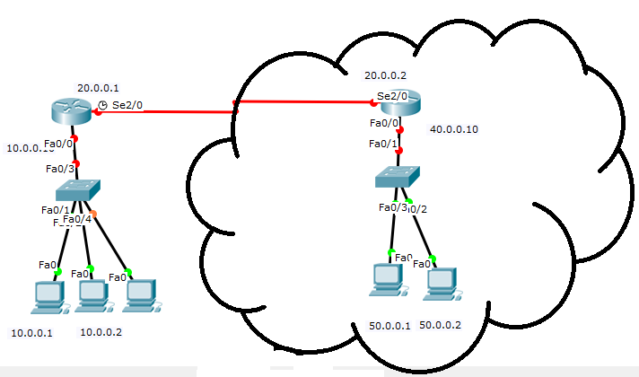

hostname R1

interface fastEthernet 0/0

ip address 10.0.0.10 255.0.0.0

no shutdown

exi

interface serial 2/0

ip address 20.0.0.1 255.0.0.0

no shutdown

exi

hostname R2

interface fastEthernet 0/0

ip address 50.0.0.10 255.0.0.0

no sh

exi

interface serial 2/0

ip address 20.0.0.02 255.0.0.0

no sh

exi

interface serial 3/0

ip address 30.0.0.2 255.0.0.0

no sh

exi

R1

ip route 0.0.0.0 0.0.0.0 20.0.0.2

R2

ip route 70.0.0.0 255.0.0.0 20.0.0.1

**R1 – Static nat**

ip nat inside source static 10.0.0.1 70.0.0.1

ip nat inside source static 10.0.0.2 70.0.0.2

exi

interface fastEthernet 0/0

ip nat inside

exi

interface serial 2/0

ip nat outside

exi

**R1 – Dynamic nat**

access-list 55 permit 10.0.0.0 0.255.255.255

ip nat pool ccna 70.0.0.1 70.0.0.10 netmask 255.0.0.0

ip nat inside source list 55 pool ccna

**R1 – Overload nat / PAT**

access-list 55 permit 10.0.0.0 0.255.255.255

ip nat pool ccna 70.0.0.1 ***70.0.0.1*** netmask ***255.255.255.255***

ip nat inside source list 55 pool ccna ***overload***

**IPV6**

Static routing



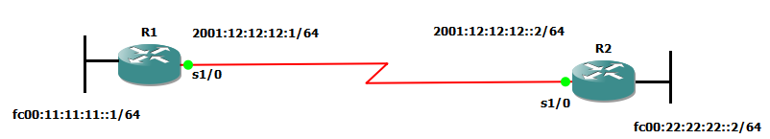

interface serial 1/0

ipv6 address 2001:12:12:12::1/64

no sh

exi

interface serial 1/1

ipv6 address fc00:11:11:11::1/64

no sh

no keepalive

exi

ipv6 route FC00:22:22:22::/64 2001:12:12:12::2

exi

R2

interface serial 1/0

ipv6 address 2001:12:12:12::2/64

no sh

exi

interface serial 1/1

ipv6 address fc00:22:22:22::2/64

no sh

no keepalive

exi

ipv6 route FC00:11:11:11::/64 2001:12:12:12::1

exi

**IPV6 Dynamic routing**

IPV6 routing types – Static , RIP ng , OSPF V3 , EIGRP – IPV6 unicast routing

Static routing





interface serial 1/0

ipv6 address 2001:12:12:12::1/64

no sh

exi

interface serial 1/1

ipv6 address fc00:11:11:11::1/64

no sh

no keepalive

exi

ipv6 route FC00:22:22:22::/64 2001:12:12:12::2

exi

R2

interface serial 1/0

ipv6 address 2001:12:12:12::2/64

no sh

exi

interface serial 1/1

ipv6 address fc00:22:22:22::2/64

no sh

no keepalive

exi

ipv6 route FC00:11:11:11::/64 2001:12:12:12::1

exi

***************************

EIGRP Lab Packet tracer lab

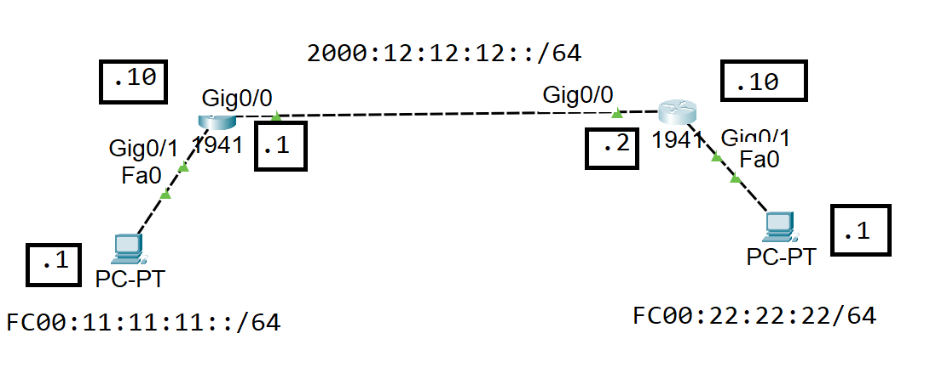

hostname RTR1

interface gigabitEthernet 0/1

no shutdown

ipv6 address fc00:11:11:11::10/64

exit

interface gigabitEthernet 0/0

no shutdown

ipv6 address 2000:12:12:12::1/64

no shutdown

exit

ipv6 unicast-routing

ipv6 router eigrp 100

eigrp router-id 2.2.2.2

no shutdown

exit

interface gigabitEthernet 0/0

ipv6 eigrp 100

exit

interface gigabitEthernet 0/1

ipv6 eigrp 100

exit

R2

R2

hostname RTR1

interface gigabitEthernet 0/0

no shutdown

ipv6 address fc00:22:22:22::10/64

exit

interface gigabitEthernet 0/1

no shutdown

ipv6 address 2000:12:12:12::2/64

no shutdown

exit

ipv6 unicast-routing

ipv6 router eigrp 100

eigrp router-id 1.1.1.1

no shutdown

exit

interface gigabitEthernet 0/0

ipv6 eigrp 100

exit

interface gigabitEthernet 0/1

ipv6 eigrp 100

exit

-----------------END OF EIGRP-----------------

RIP ng Packet tracer lab

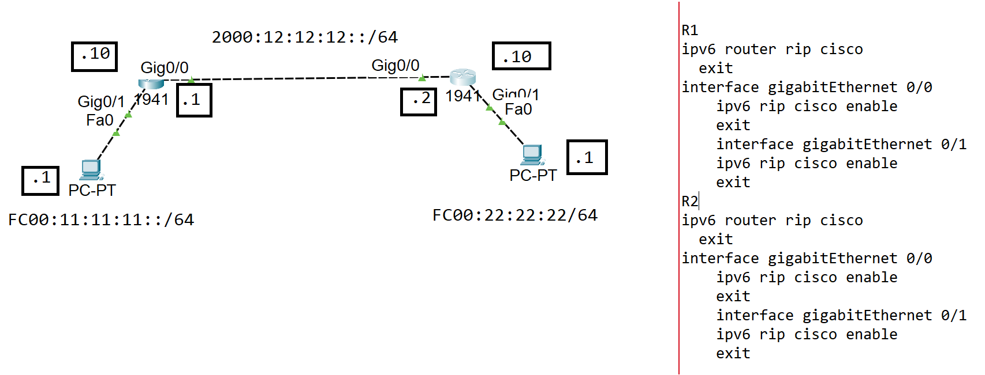

R1

ipv6 router rip cisco

exit

interface gigabitEthernet 0/0

ipv6 rip cisco enable

exit

interface gigabitEthernet 0/1

ipv6 rip cisco enable

exit

R2

ipv6 router rip cisco

exit

interface gigabitEthernet 0/0

ipv6 rip cisco enable

exit

interface gigabitEthernet 0/1

ipv6 rip cisco enable

exit

**Summarization with EIGRP**

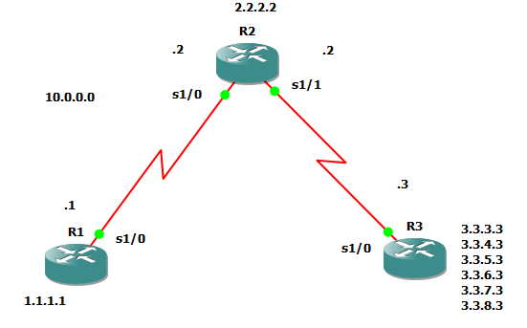

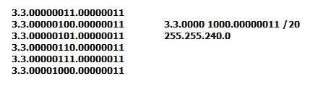

R1

interface loopback 1

ip address 1.1.1.1 255.255.255.255

exi

interface fa 0/0

ip address 10.0.0.1 255.255.255.0

no sh

exi

**R2**

interface fa 0/0

ip address 10.0.0.2 255.255.255.0

no shutdown

exi

interface fa 0/1

ip address 20.0.0.2 255.255.255.0

no shutdown

exi

interface loopback 2

ip address 2.2.2.2 255.255.255.255

exi

**R3**

interface fa 0/0

no sh

ip address 20.0.0.3 255.255.255.0

exi

interface loopback 1

ip address 3.3.3.3 255.255.255.0

exi

interface loopback 2

ip address 3.3.4.3 255.255.255.0

exi

interface loopback 3

ip address 3.3.5.3 255.255.255.0

exi

interface loopback 4

ip address 3.3.6.3 255.255.255.0

exi

interface loopback 5

ip address 3.3.7.3 255.255.255.0

exi

interface loopback 6

ip address 3.3.7.3 255.255.255.0

exi

interface loopback 6

ip address 3.3.8.3 255.255.255.0

exi

**R1**

router eigrp 100

network 1.0.0.0

network 10.0.0.0

no auto

exi

**R2**

router eigrp 100

network 10.0.0.0

network 20.0.0.0

network 2.0.0.0

no auto

exi

**R3**

router eigrp 100

network 20.0.0.0

network 3.0.0.0

no auto

exi

In **R2** show ip route before giving No autosummary

D 1.0.0.0/8 [90/2297856] via 10.0.0.1, 00:00:55, Serial1/0

2.0.0.0/8 is variably subnetted, 2 subnets, 2 masks

C 2.2.2.2/32 is directly connected, Loopback2

D 2.0.0.0/8 is a summary, 00:00:45, Null0

D 3.0.0.0/8 [90/2297856] via 20.0.0.3, 00:00:18, Serial1/1

20.0.0.0/8 is variably subnetted, 2 subnets, 2 masks

C 20.0.0.0/24 is directly connected, Serial1/1

D 20.0.0.0/8 is a summary, 00:00:52, Null0

10.0.0.0/8 is variably subnetted, 2 subnets, 2 masks

C 10.0.0.0/24 is directly connected, Serial1/0

D 10.0.0.0/8 is a summary, 00:00:52, Null0

In **R2** show ip route after giving No autosummary

D 1.0.0.0/8 [90/2297856] via 10.0.0.1, 00:01:55, Serial1/0

2.0.0.0/32 is subnetted, 1 subnets

C 2.2.2.2 is directly connected, Loopback2

3.0.0.0/24 is subnetted, 6 subnets

D 3.3.3.0 [90/2297856] via 20.0.0.3, 00:00:33, Serial1/1

D 3.3.4.0 [90/2297856] via 20.0.0.3, 00:00:33, Serial1/1

D 3.3.5.0 [90/2297856] via 20.0.0.3, 00:00:33, Serial1/1

D 3.3.6.0 [90/2297856] via 20.0.0.3, 00:00:33, Serial1/1

D 3.3.7.0 [90/2297856] via 20.0.0.3, 00:00:33, Serial1/1

D 3.3.8.0 [90/2297856] via 20.0.0.3, 00:00:33, Serial1/1

20.0.0.0/24 is subnetted, 1 subnets

C 20.0.0.0 is directly connected, Serial1/1

10.0.0.0/24 is subnetted, 1 subnets

**R3**

interface fa 0/0

ip summary-address eigrp 100 3.3.0.0 255.255.240.0

exit

After this command

**R2**

Show ip route

Gateway of last resort is not set

D 1.0.0.0/8 [90/2297856] via 10.0.0.1, 00:14:46, Serial1/0

2.0.0.0/32 is subnetted, 1 subnets

C 2.2.2.2 is directly connected, Loopback2

**3.0.0.0/20 is subnetted, 1 subnets**

D 3.3.0.0 [90/2297856] via 20.0.0.3, 00:00:24, Serial1/1

20.0.0.0/24 is subnetted, 1 subnets

C 20.0.0.0 is directly connected, Serial1/1

10.0.0.0/24 is subnetted, 1 subnets

C 10.0.0.0 is directly connected, Serial1/0

R2#

**Authentication - EIGRP**

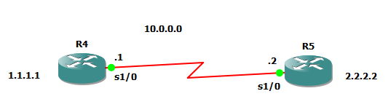

**R4**

interface loopback 1

ip address 1.1.1.1 255.255.255.255

no sh

exi

interface fa 0/0

ip address 10.0.0.1 255.0.0.0

no sh

exi

router eigrp 100

network 1.0.0.0

network 10.0.0.0

no auto-summary

exi

**R5**

interface loopback 2

ip address 2.2.2.2 255.255.255.255

exi

interface fa 0/0

ip address 10.0.0.2 255.0.0.0

no sh

exi

router eigrp 100

network 2.0.0.0

network 10.0.0.0

no auto-summary

exit

First we need to create the Key chain - Using the Key-string and Key Number it will create a hash value which has match on both sides. Key chain has to be same on both the routers .

**R4**

key chain R1

key 20

key-string cisco

exi

interface fa 0/0

ip authentication mode eigrp 100 md5

ip authentication key-chain eigrp 100 R1

exi

**Show ip route**

**R5**

key chain R1

key 20

key-string cisco

exi

interface fa 0/0

ip authentication mode eigrp 100 md5

ip authentication key-chain eigrp 100 R1

exi

**Show ip route**

**Routing information protocol – Authentication**

**R4**

key chain R2

key 20

key-string cisco

exi

interface fa 0/0

ip rip authentication mode md5

ip rip authentication key-chain R2

exi

**R5**

key chain R2

key 20

key-string cisco

exi

interface fa 0/0

ip rip authentication mode md5

ip rip authentication key-chain R2

exi

**OSPF Authentication**

**r1**

router ospf 10

network 10.0.0.0 0.255.255.255 area 0

network 1.1.1.1 0.0.0.0 area 0

exi

**r2**

router ospf 10

network 2.0.0.0 0.0.0.0 area 0

network 10.0.0.0 0.255.255.255 area 0

exi

**r1**

interface fa 0/0

ip ospf authentication message-digest

ip ospf message-digest-key 5 md5 cisco

exi

**r2**

interface fa 0/0

ip ospf authentication message-digest

ip ospf message-digest-key 2 md5 cisco

end

**Redistribution**

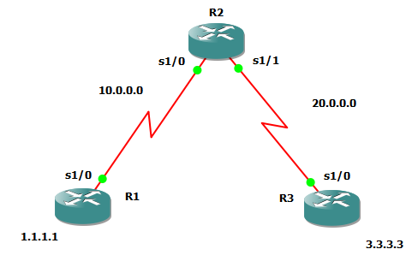

**R1**

interface loopback 1

ip address 1.1.1.1 255.255.255.255

no sh

exi

interface serial 1/0

no sh

ip address 10.0.0.1 255.0.0.0

exi

router rip

version 2

network 1.0.0.0

no auto-summary

network 10.0.0.0

exi

**R2**

interface serial 1/0

ip address 10.0.0.2 255.0.0.0

no sh

exi

interface serial 1/1

ip address 20.0.0.2 255.0.0.0

no sh

exi

router rip

version 2

no auto

network 10.0.0.0

router eigrp 100

network 20.0.0.0

no auto-summary

exi

**R3**

interface serial 1/0

no sh

ip address 20.0.0.3 255.0.0.0

exi

interface loopback 3

ip address 3.3.3.3 255.255.255.255

exi

router eigrp 100

network 3.0.0.0

no auto-summary

network 20.0.0.0

exi

**Show ip route**

**R2**

router rip

redistribute eigrp 100 metric 3

exi

router eigrp 100

redistribute rip metric 1000 2000 255 1 1500

exi

**Show ip route**

**R1**

router rip

version 2

network 1.0.0.0

no auto-summary

network 10.0.0.0

exi

**R2**

router rip

version 2

no auto

network 10.0.0.0

exit

router ospf 10

network 20.0.0.0 0.255.255.255 area 0

exi

**R3**

router ospf 100

network 20.0.0.0 0.255.255.255 area 0

network 3.3.3.3 0.0.0.0 area 0

exit

**R2**

router rip

redistribute ospf 10 metric 5

exi

Classfull

router ospf 10

redistribute rip

exi

Classless

router ospf 10

redistribute rip **subnets**

exi

Show ip route

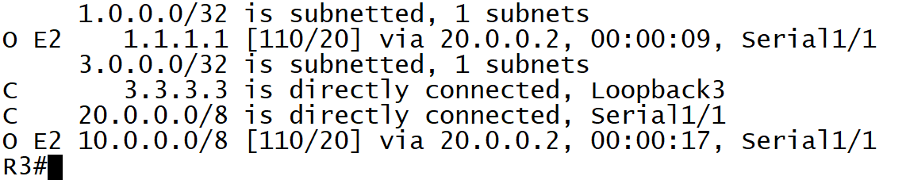

In OSPF there is no need to explicitly mention the metric cost like other protocols because in OSPF all redistributed external routes will have a default cost of 20

router ospf 10

redistribute rip **subnets** **metric 100**

exi

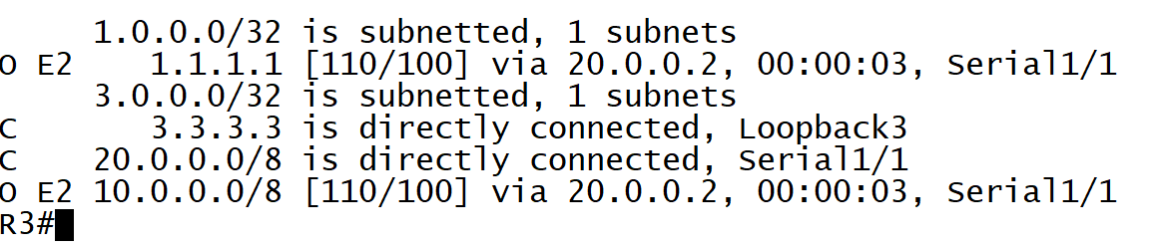

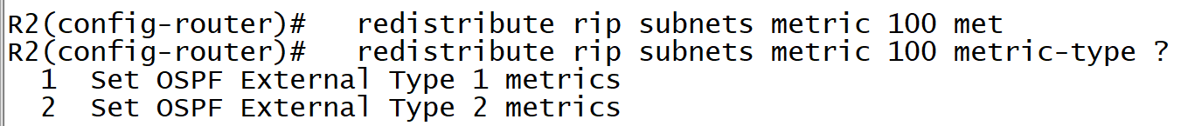

Type 2 will add cost of 100 for all routers path cost

But Type 1 will also add the indivisual cost along with 100

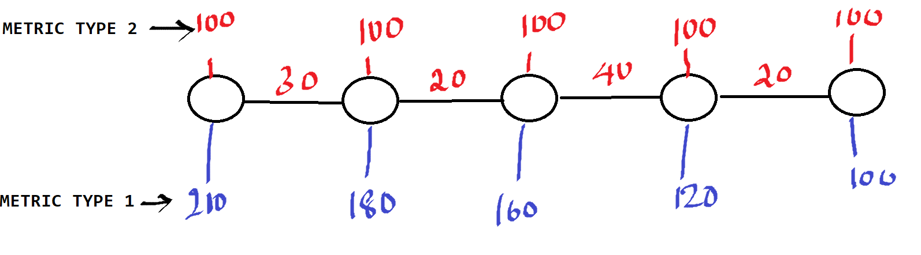

router ospf 10

redistribute rip **subnets** **metric 100 metric-type 1**

exi

**NOTE:** Metric and Metric type are optional Baceuse by default ospf takes all external routes metric as 20 . In R3 show ip route ospf .

If we don’t give “ SUBNETS “ command by default OSPF will only redistribute classfull networks ,

**Show ip route**

**Summarization with EIGRP**





R1

interface loopback 1

ip address 1.1.1.1 255.255.255.255

exi

interface fa 0/0

ip address 10.0.0.1 255.255.255.0

no sh

exi

**R2**

interface fa 0/0

ip address 10.0.0.2 255.255.255.0

no shutdown

exi

interface fa 0/1

ip address 20.0.0.2 255.255.255.0

no shutdown

exi

interface loopback 2

ip address 2.2.2.2 255.255.255.255

exi

**R3**

interface fa 0/0

no sh

ip address 20.0.0.3 255.255.255.0

exi

interface loopback 1

ip address 3.3.3.3 255.255.255.0

exi

interface loopback 2

ip address 3.3.4.3 255.255.255.0

exi

interface loopback 3

ip address 3.3.5.3 255.255.255.0

exi

interface loopback 4

ip address 3.3.6.3 255.255.255.0

exi

interface loopback 5

ip address 3.3.7.3 255.255.255.0

exi

interface loopback 6

ip address 3.3.7.3 255.255.255.0

exi

interface loopback 6

ip address 3.3.8.3 255.255.255.0

exi

**R1**

router eigrp 100

network 1.0.0.0

network 10.0.0.0

no auto

exi

**R2**

router eigrp 100

network 10.0.0.0

network 20.0.0.0

network 2.0.0.0

no auto

exi

**R3**

router eigrp 100

network 20.0.0.0

network 3.0.0.0

no auto

exi

In **R2** show ip route before giving No autosummary

D 1.0.0.0/8 [90/2297856] via 10.0.0.1, 00:00:55, Serial1/0

2.0.0.0/8 is variably subnetted, 2 subnets, 2 masks

C 2.2.2.2/32 is directly connected, Loopback2

D 2.0.0.0/8 is a summary, 00:00:45, Null0

D 3.0.0.0/8 [90/2297856] via 20.0.0.3, 00:00:18, Serial1/1

20.0.0.0/8 is variably subnetted, 2 subnets, 2 masks

C 20.0.0.0/24 is directly connected, Serial1/1

D 20.0.0.0/8 is a summary, 00:00:52, Null0

10.0.0.0/8 is variably subnetted, 2 subnets, 2 masks

C 10.0.0.0/24 is directly connected, Serial1/0

D 10.0.0.0/8 is a summary, 00:00:52, Null0

In **R2** show ip route after giving No autosummary

D 1.0.0.0/8 [90/2297856] via 10.0.0.1, 00:01:55, Serial1/0

2.0.0.0/32 is subnetted, 1 subnets

C 2.2.2.2 is directly connected, Loopback2

3.0.0.0/24 is subnetted, 6 subnets

D 3.3.3.0 [90/2297856] via 20.0.0.3, 00:00:33, Serial1/1

D 3.3.4.0 [90/2297856] via 20.0.0.3, 00:00:33, Serial1/1

D 3.3.5.0 [90/2297856] via 20.0.0.3, 00:00:33, Serial1/1

D 3.3.6.0 [90/2297856] via 20.0.0.3, 00:00:33, Serial1/1

D 3.3.7.0 [90/2297856] via 20.0.0.3, 00:00:33, Serial1/1

D 3.3.8.0 [90/2297856] via 20.0.0.3, 00:00:33, Serial1/1

20.0.0.0/24 is subnetted, 1 subnets

C 20.0.0.0 is directly connected, Serial1/1

10.0.0.0/24 is subnetted, 1 subnets

**R3**

interface fa 0/0

ip summary-address eigrp 100 3.3.0.0 255.255.240.0

exit

After this command

**R2**

Show ip route

Gateway of last resort is not set

D 1.0.0.0/8 [90/2297856] via 10.0.0.1, 00:14:46, Serial1/0

2.0.0.0/32 is subnetted, 1 subnets

C 2.2.2.2 is directly connected, Loopback2

**3.0.0.0/20 is subnetted, 1 subnets**

D 3.3.0.0 [90/2297856] via 20.0.0.3, 00:00:24, Serial1/1

20.0.0.0/24 is subnetted, 1 subnets

C 20.0.0.0 is directly connected, Serial1/1

10.0.0.0/24 is subnetted, 1 subnets

C 10.0.0.0 is directly connected, Serial1/0

R2#

**Authentication - EIGRP**



**R4**

interface loopback 1

ip address 1.1.1.1 255.255.255.255

no sh

exi

interface fa 0/0

ip address 10.0.0.1 255.0.0.0

no sh

exi

router eigrp 100

network 1.0.0.0

network 10.0.0.0

no auto-summary

exi

**R5**

interface loopback 2

ip address 2.2.2.2 255.255.255.255

exi

interface fa 0/0

ip address 10.0.0.2 255.0.0.0

no sh

exi

router eigrp 100

network 2.0.0.0

network 10.0.0.0

no auto-summary

exit

First we need to create the Key chain - Using the Key-string and Key Number it will create a hash value which has match on both sides. Key chain has to be same on both the routers .

**R4**

key chain R1

key 20

key-string cisco

exi

interface fa 0/0

ip authentication mode eigrp 100 md5

ip authentication key-chain eigrp 100 R1

exi

**Show ip route**

**R5**

key chain R1

key 20

key-string cisco

exi

interface fa 0/0

ip authentication mode eigrp 100 md5

ip authentication key-chain eigrp 100 R1

exi

**Show ip route**

**Routing information protocol – Authentication**

**R4**

key chain R2

key 20

key-string cisco

exi

interface fa 0/0

ip rip authentication mode md5

ip rip authentication key-chain R2

exi

**R5**

key chain R2

key 20

key-string cisco

exi

interface fa 0/0

ip rip authentication mode md5

ip rip authentication key-chain R2

exi

**OSPF Authentication**

**r1**

router ospf 10

network 10.0.0.0 0.255.255.255 area 0

network 1.1.1.1 0.0.0.0 area 0

exi

**r2**

router ospf 10

network 2.0.0.0 0.0.0.0 area 0

network 10.0.0.0 0.255.255.255 area 0

exi

**r1**

interface fa 0/0

ip ospf authentication message-digest

ip ospf message-digest-key 5 md5 cisco

exi

**r2**

interface fa 0/0

ip ospf authentication message-digest

ip ospf message-digest-key 2 md5 cisco

end

**Redistribution**



**R1**

interface loopback 1

ip address 1.1.1.1 255.255.255.255

no sh

exi

interface serial 1/0

no sh

ip address 10.0.0.1 255.0.0.0

exi

router rip

version 2

network 1.0.0.0

no auto-summary

network 10.0.0.0

exi

**R2**

interface serial 1/0

ip address 10.0.0.2 255.0.0.0

no sh

exi

interface serial 1/1

ip address 20.0.0.2 255.0.0.0

no sh

exi

router rip

version 2

no auto

network 10.0.0.0

router eigrp 100

network 20.0.0.0

no auto-summary

exi

**R3**

interface serial 1/0

no sh

ip address 20.0.0.3 255.0.0.0

exi

interface loopback 3

ip address 3.3.3.3 255.255.255.255

exi

router eigrp 100

network 3.0.0.0

no auto-summary

network 20.0.0.0

exi

**Show ip route**

**R2**

router rip

redistribute eigrp 100 metric 3

exi

router eigrp 100

redistribute rip metric 1000 2000 255 1 1500

exi

**Show ip route**

**R3**

router ospf 100

network 20.0.0.0 0.255.255.255 area 0

network 3.3.3.3 0.0.0.0 area 0

exit

**R2**

router ospf 10

network 20.0.0.0 0.255.255.255 area 0

exi

router rip

redistribute ospf 10 metric 5

exi

router ospf 10

redistribute rip **subnets** **metric 100 metric-type 1**

exi

**NOTE:** If I say “ redistribute rip - enter“ it will take classfull , Metric and Metric type are optional Baceuse by default ospf takes all external routes metric as 20 . In R3 show ip route ospf .

If we don’t give “ SUBNETS “ command by default OSPF will only redistribute classfull networks ,

**Show ip route**

**Policy Based Routing , route map**

**Route MAP**

Route maps are **used when redistributing routes into an OSPF, RIP, or EIGRP routing process**. They are also used when generating a default route into an Any routing process. A route map defines which of the routes from the specified routing protocol are allowed to be redistributed into the target routing process based on the parameters as per the requirement.

Requirement : 3.3.3.0 and 3.3.4.0 should get advertised in to OSPF with a metric value of 1000

3.3.5.0 and 3.3.6.0 should get advertised in to OSPF with a metric value of 2000

3.3.7.0 and 3.3.8.0 should get advertised in to OSPF with a metric value of 3000

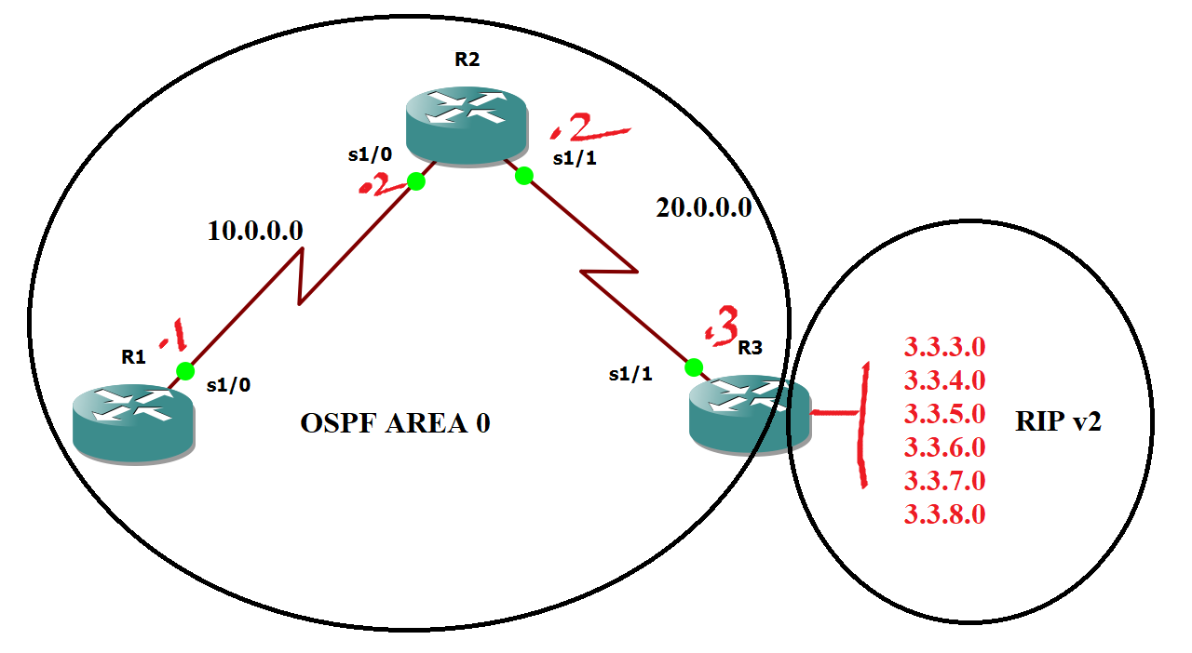

interface loopback 1

ip address 1.1.1.1 255.255.255.255

exi

interface SE 1/0

ip address 10.0.0.1 255.255.255.0

no sh

exi

**R2**

interface se 1/0

ip address 10.0.0.2 255.255.255.0

no shutdown

exi

interface se 1/1

ip address 20.0.0.2 255.255.255.0

no shutdown

exi

interface loopback 2

ip address 2.2.2.2 255.255.255.255

exi

**R3**

interface se 1/1

no sh

ip address 20.0.0.3 255.255.255.0

exi

interface loopback 1

ip address 3.3.3.3 255.255.255.0

exi

interface loopback 2

ip address 3.3.4.3 255.255.255.0

exi

interface loopback 3

ip address 3.3.5.3 255.255.255.0

exi

interface loopback 4

ip address 3.3.6.3 255.255.255.0

exi

interface loopback 5

ip address 3.3.7.3 255.255.255.0

exi

interface loopback 6

ip address 3.3.7.3 255.255.255.0

exi

interface loopback 6

ip address 3.3.8.3 255.255.255.0

exi

**R1**

router ospf 10

network 1.0.0.0 0.255.255.255 area 0

network 10.0.0.0 0.255.255.255 area 0

exi

**R2**

router ospf 100

network 10.0.0.0 0.255.255.255 area 0

network 20.0.0.0 0.255.255.255 area 0

network 2.0.0.0 0.255.255.255 area 0

exi

**R3**

router rip

ver 2

network 3.0.0.0

no auto

exi

router ospf 100

network 20.0.0.0 0.255.255.255 area 0

Exit

R3

router ospf 100

redistribute rip subnets metric 100 metric-type 2

exi

**NOTE:** A type 1 (Calculated cost) route has a metric that is the sum of the internal OSPF cost and the external redistributed cost. A type 2 (Default cost) route has a metric equal only to the redistributed cost,

**1.Match the Networks**

access-list 11 permit 3.3.3.0 0.0.0.255

access-list 11 permit 3.3.4.0 0.0.0.255

access-list 21 permit 3.3.5.0 0.0.0.255

access-list 21 permit 3.3.6.0 0.0.0.255

access-list 31 permit 3.3.7.0 0.0.0.255

access-list 31 permit 3.3.8.0 0.0.0.255

**2.Implement Route-map**

route-map CCNP permit 10

match ip address 11

set metric 1000

exit

route-map CCNP permit 20

match ip address 21

set metric 2000

exit

route-map CCNP permit 30

match ip address 31

set metric 3000

exit

**3.Use route-map**

router ospf 10

redistribute rip subnets route-map CCNP

64 – It will also add wan interface cost

**Policy based routing**

Policy based routing – Routing done based on the policies defined by the administrator. Routing will not be done based on the routing table than the routing will be done based on certain policy based on certain route map statements.

PBR will be implemented on the incoming direction of the source interface.

Requirement : 1.1.1.1 should always use 20.0.0.3 as the next hop

1.1.2.1 should always use 30.0.0.3 as the next hop

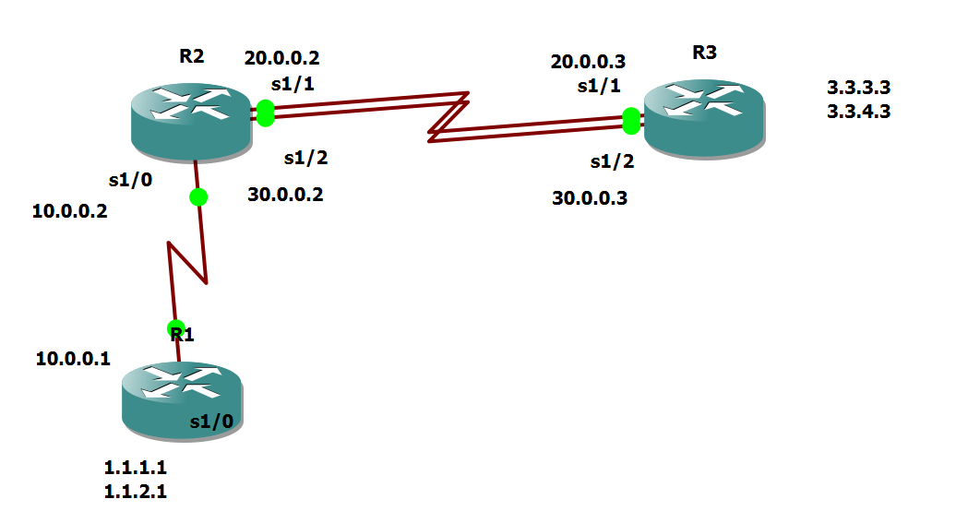

R1

interface se 1/0

no shutdown

ip address 10.0.0.1 255.0.0.0

exit

interface loopback 1

ip address 1.1.1.1 255.255.255.0

no sh

exit

interface loopback 2

ip address 1.1.2.1 255.255.255.0

no sh

exit

router eigrp 100

no auto-summary

network 1.0.0.0

network 10.0.0.0

exit

R2

interface se 1/0

no sh

ip address 10.0.0.2 255.0.0.0

exit

interface serial 1/1

no shutdown

ip address 20.0.0.2 255.0.0.0

no sh

exit

interface serial 1/2

no shutdown

ip address 30.0.0.2 255.0.0.0

exit

router eigrp 100

network 10.0.0.0

network 20.0.0.0

network 30.0.0.0

no auto-summary

exit

access-list 10 permit 1.1.1.0 0.0.0.255

access-list 11 permit 1.1.2.0 0.0.0.255

route-map CCNA permit 10

match ip address 10

set ip next-hop 20.0.0.3

exit

route-map CCNA permit 20

match ip address 11

set ip next-hop 30.0.0.3

exit

interface se 1/0

ip policy route-map CCNA

exit

R3

interface serial 1/1

ip address 20.0.0.3 255.0.0.0

no shutdown

exit

interface serial 1/2

ip address 30.0.0.3 255.0.0.0

no shutdown

exit

interface loopback 3

no shutdown

ip address 3.3.3.3 255.255.255.0

exit

router eigrp 100

network 20.0.0.0

network 30.0.0.0

no auto-summary

network 3.0.0.0

exit

Change the Bandwidth of R2 Serial 1/1 – 1000 and check the flow of traffic using Traceroute

**HSRP**

Hot Standby Router Protocol (HSRP) is a CISCO proprietary protocol, which provides redundancy for a local subnet. In HSRP, two or more routers gives an illusion of a virtual router.

HSRP allows you to configure two or more routers as standby routers and only a single router as an active router at a time. All the routers in a single HSRP group shares a single MAC address and IP address, which acts as a default gateway to the local network. The Active router is responsible for forwarding the traffic. If it fails, the Standby router takes up all the responsibilities of the active router and forwards the traffic.

#### Some important terms related to HSRP :

1. **Virtual IP :**IP address from local subnet is assigned as default gateway to all local hosts in the network.
2. **Virtual MAC address** : MAC address is generated automatically by HSRP. The first 24 bits will be default CISCO address (i.e. 0000.0c). The next 16 bits are **HSRP ID** (i.e. 07.ac). The next 8 bits will be the group number in hexadecimal. e.g- if the group number is 10 then the last 8 bits will be 0a.  
      
   Example of virtual MAC address –

0000.0c07.ac0a

1. **Hello messages :**Periodic messages exchanged by active and standby routers. These messages are exchanged after every 3 seconds telling the state of router.
2. **Hold down timer :**Its default value is 10 seconds i.e roughly 3 times the value of hello message. This timer tells us about the router that how much time will the standby router waits for hello message if it is not received on time.

***Note :****If the active router fails then the standby router will become the active router.*

1. **Priority :**By default, the priority value is 100. It is helpful when the active router comes back after falling down, we can change the priority of standby router (which has become the active router after the original active router is down) to less than 100 therefore it again becomes standby router.

***Note :****The router having higher priority will become the active router.*

1. **Preempt :**It is a state in which the standby router automatically becomes the active router.
2. **No load balancing and it supports IPV6.**

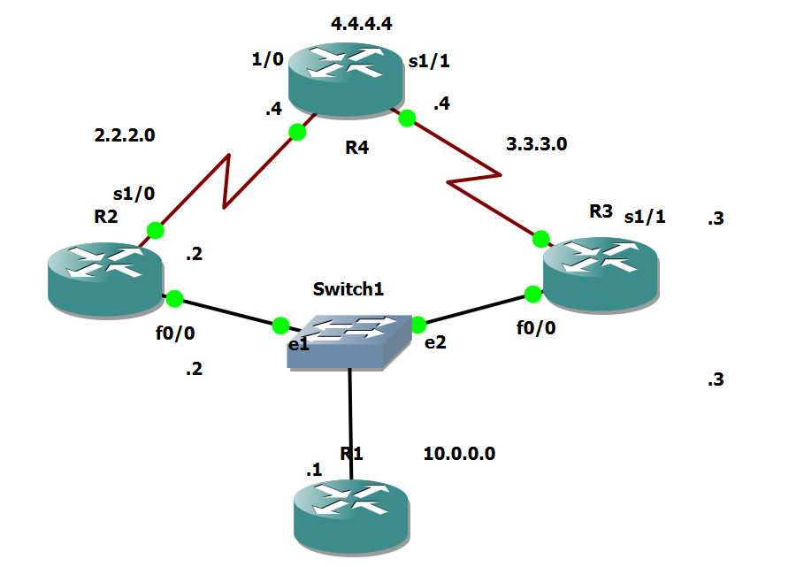

**PC**

interface fastEthernet 0/0

no shutdown

ip address 10.0.0.1 255.0.0.0

exit

no ip routing

ip default-gateway 10.0.0.2

ip default-gateway 10.0.0.3

ip default-gateway 10.0.0.10

R2

Interface fa0/0

No sh

ip address 10.0.0.2 255.0.0.0

exit

interface serial 2/0

ip address 2.2.2.2 255.0.0.0

no sh

exi

ip route 0.0.0.0 0.0.0.0 2.2.2.3

interface fastEthernet 0/0

standby 1 ip 10.0.0.10

standby 1 preempt

R4

interface fastEthernet 0/0

no shutdown

ip address 10.0.0.4 255.0.0.0

exit

interface serial 2/0

no shutdown

ip address 3.3.3.4 255.0.0.0

no sh

exit

ip route 0.0.0.0 0.0.0.0 3.3.3.3

interface fastEthernet 0/0

standby 1 ip 10.0.0.10

standby 1 preempt

exit

R3

interface serial 2/0

no shutdown

ip address 2.2.2.3 255.0.0.0

exit

interface serial 3/0

no shutdown

ip address 3.3.3.3 255.0.0.0

exit

interface loopback 4

ip address 4.4.4.4 255.0.0.0

exit

ip route 10.0.0.0 255.0.0.0 2.2.2.2

ip route 10.0.0.0 255.0.0.0 3.3.3.4

**Password recovery .**

Physical OFF and ON

CTR+SHIFT+PAUSE/BREAK (Pause/Break or equivalent command depends upon diff laptops)

Self decompressing the image :

#################################

monitor: command "boot" aborted due to user interrupt

rommon 1 > confreg 2142

rommon 2 > reset

Continue with configuration dialog? [yes/no]:no

Router>enab

Router#conf t

Router(config)#no enable password

Router(config)#no enable secret

Router#show version

Configuration register is 0x2142

Router(config)#config-register 2102

Router#reload

This time it will not ask for the password.

**ROUTER IOS RESTORE**

IP_ADDRESS: The IP address for this unit – Router IP address

IP_SUBNET_MASK: The subnet mask for this unit – Subnet mask of the router

DEFAULT_GATEWAY: The default gateway for this unit - Router IP address

TFTP_SERVER: The IP address of the server to fetch from – Server IP address

TFTP_FILE: The filename to fetch – Image file

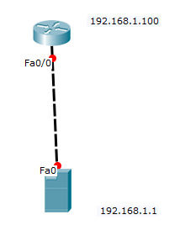

TFTPDNLD

IP_ADDRESS=192.168.1.100

IP_SUBNET_MASK=255.255.255.0

DEFAULT_GATEWAY=192.168.1.100

TFTP_SERVER=192.168.1.1

TFTP_FILE=pt1000-i-mz.122-28.bin

TFTPDNLD

Do you wish to continue - Yes

Reset

**Troubleshooting connectivity.**

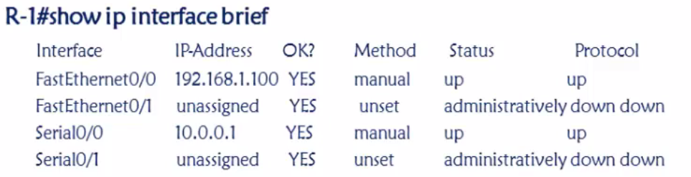



PPP –

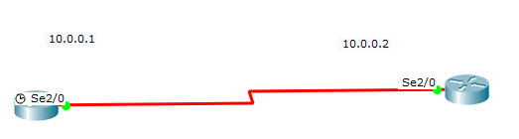

**CHAP Configuration**

Show interfaces serial 2/0

hostname R1

interface serial 2/0

ip address 10.0.0.1 255.0.0.0

no sh

exi

interface serial 2/0

encapsulation ppp

ppp authentication chap

exi

exi

username R2 password cisco

hostname R2

interface serial 2/0



ip address 10.0.0.2 255.0.0.0

no sh

exi

interface serial 2/0

encapsulation ppp



ppp authentication chap

exi

exi



username R1 password cisco



**PAP Configuration**

Show interfaces serial 2/0

interface serial 2/0

encapsulation ppp

ppp authentication pap

ppp pap sent-username R1 password cisco

exi

username R2 password cisco

interface serial 2/0

encapsulation ppp

ppp authentication pap

ppp pap sent-username R2 password cisco

exi

username R1 password cisco

Significance of Clock Rate

When you set the clock rate for a serial interface, you are setting the **speed of the interface**, in other words, the bandwidth (bandwidth meaning rate of data transfer). When using this command it's in the form of bits: 64000 bits = 64 kb

Router#show controllers serial 2/0

Interface Serial2/0

Hardware is PowerQUICC MPC860

DCE V.35, no clock

interface serial 2/0

clock rate 2400

**CCNA SWITCH**

**Assigning IP address to a Switch**

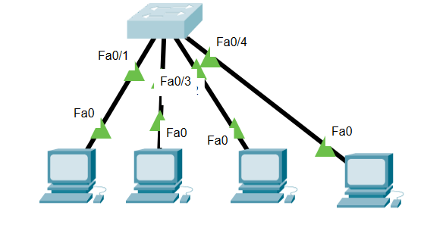

Show Vlan

interface vlan 1

no shutdown

ip address 10.0.0.100 255.0.0.0

exit

SHOW MAC-ADDRESS TABLE

SHOW VLAN

**CREATING VLANS**

vlan 10

name SALES

exit

vlan 20

name MANAGT

exit

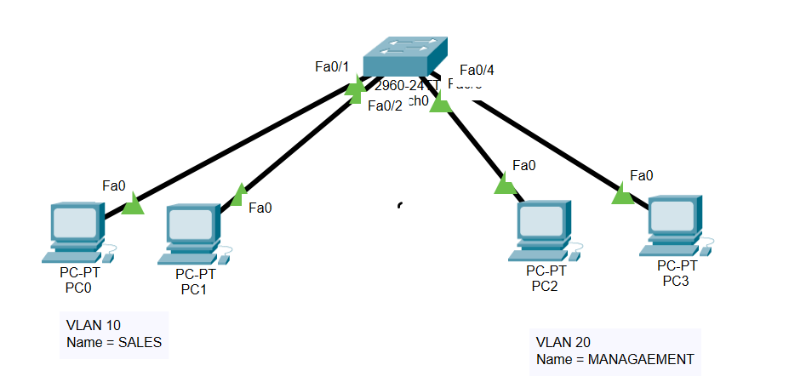

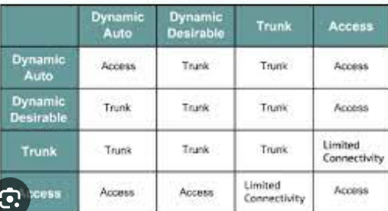

SHOW INTERfaces FAStEthernet 0/20 switchport

Which mode the switch port is in. – Dynamic Auto

Adding a port in to a Vlan

interface fastEthernet 0/1

switchport mode access

switchport access vlan 10

exit

interface fastEthernet 0/2

switchport mode access

switchport access vlan 10

exit

interface fastEthernet 0/3

switchport mode access

switchport access vlan 20

exit

interface fastEthernet 0/4

switchport mode access

switchport access vlan 20

exit

interface range fastEthernet 0/1 , fastEthernet 0/3 , fastEthernet 0/5

interface range fastEthernet 0/1 – 2

**TWO DEVICES BELONGING TO TWO DIFFERENT NETWORKS CAN NEVER EVER COMMUNICATE - UNTIL AND UNLESS -L3 DEVICE**

CONFIGURING TRUNK

interface fastEthernet 0/5

switchport mode trunk

exit

Switch#show interfaces trunk

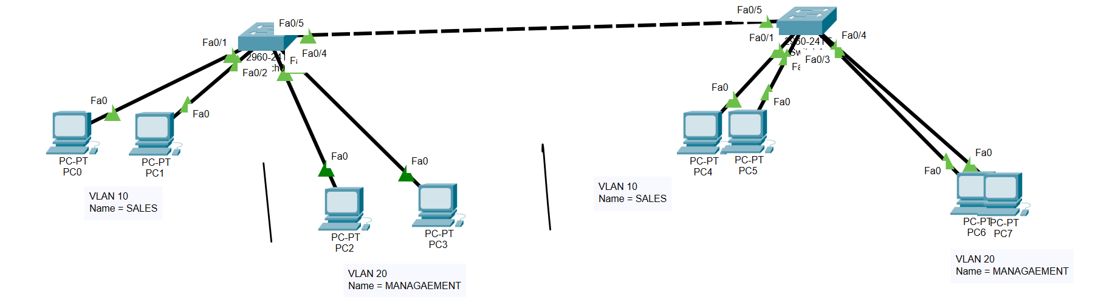

**Assigning IP address to a switch**

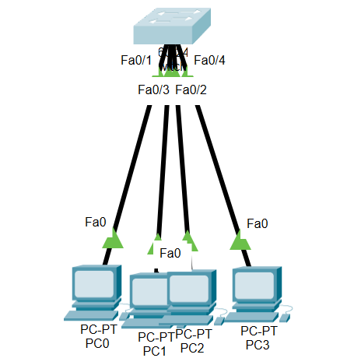

interface vlan 1

no shutdown

ip address 10.0.0.10 255.0.0.0

exi

**Inter vlan routing**

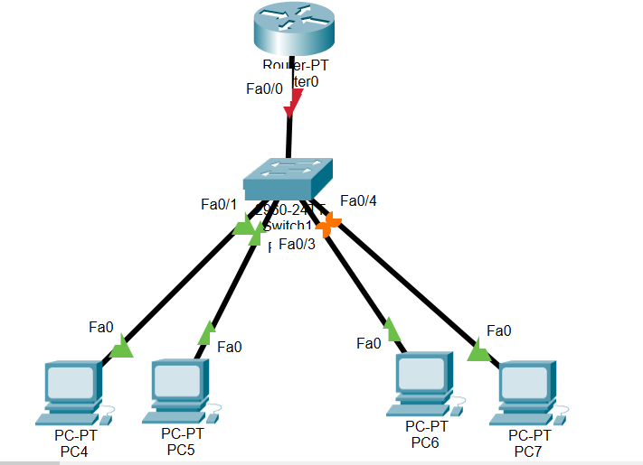

SWITCH

interface range fastEthernet 0/1 - 2

switchport mode access

switchport access vlan 10

interface range fastEthernet 0/3 - 4

switchport mode access

switchport access vlan 20

interface fastEthernet 0/5

switchport mode trunk

exit

Router

interface fastEthernet 0/0.2

encapsulation dot1Q 10

ip address 10.0.0.10 255.0.0.0

exit

interface fastEthernet 0/0.2

encapsulation dot1Q 20

ip address 20.0.0.10 255.0.0.0

exit

**Difference between L3 switch and a router**

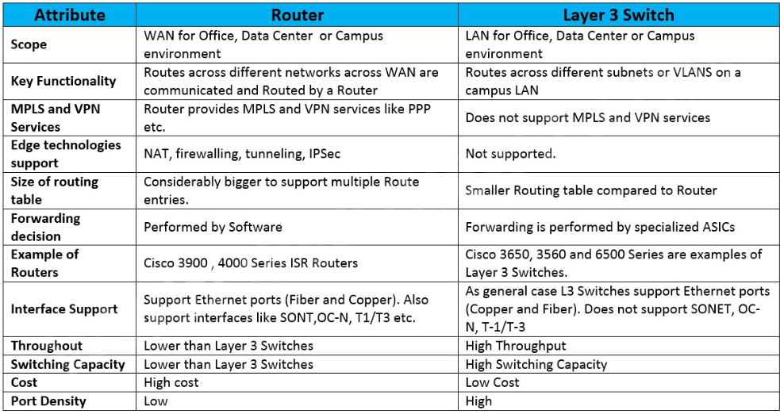

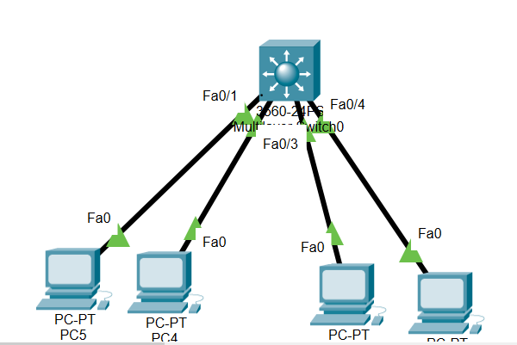

ip routing

exit

interface range fastEthernet 0/1 - 2

switchport mode access

switchport access vlan 10

exit

interface range fastEthernet 0/3 - 4

switchport mode access

switchport access vlan 20

interface vlan 10

ip address 10.0.0.10 255.0.0.0

exit

interface vlan 20

ip address 20.0.0.10 255.0.0.0

exit

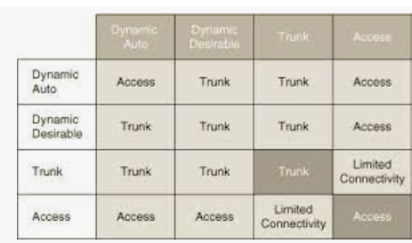

DTP modes

VTP

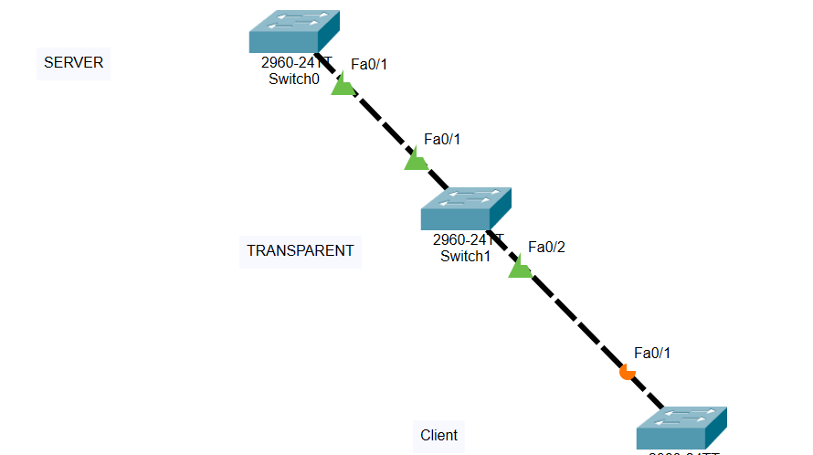

SW1

interface fastEthernet 0/1

switchport mode trunk

vtp domain CCIE

vtp mode server

vtp password cisco

vtp version 2

SW2

interface fastEthernet 0/2

switchport mode trunk

vtp domain CCIE

vtp mode transparent

vtp password cisco

vtp version 2

SW3

hostname CLIENT

vtp domain CCIE

vtp mode client

vtp password cisco

vtp version 2

Port security

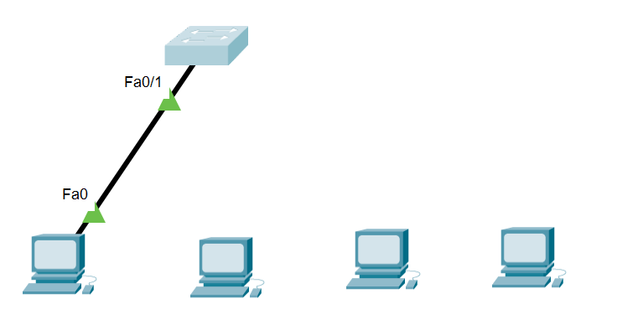

interface fastEthernet 0/2

switchport mode access

switchport port-security

switchport port-security mac-address sticky

switchport port-security maximum 2

exit

**Ether channel**

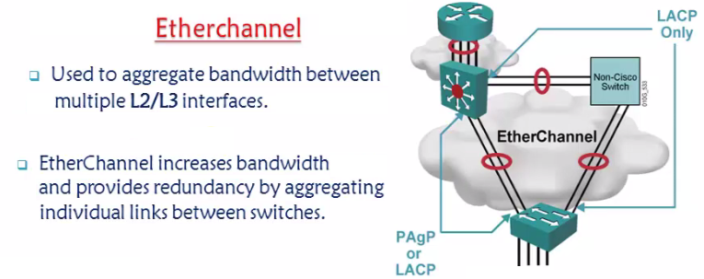

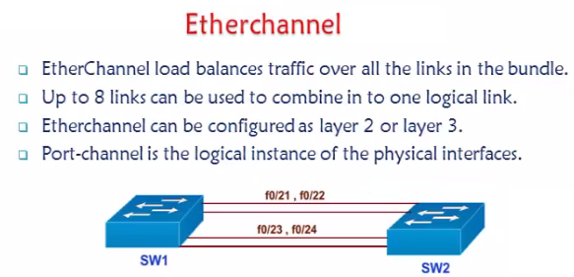

To configure etherchannel -both the switches should have same

Speed,duplex,same Vlan and same set of configurations.

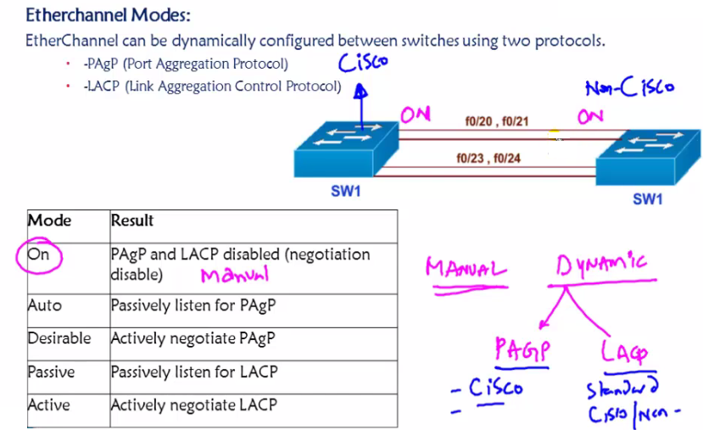

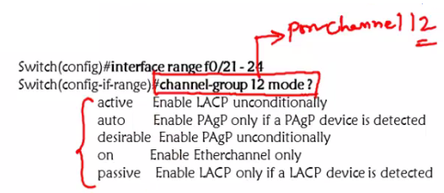

Whatever changes that we do on logical interface – same changes will happen to the physical interfaces.

Verification commands – Show ether channel summary , show ip int br ,

Any implementation on port channel will impact the indivisual switch

Switchport trunk encapsulation dot1q / ISL

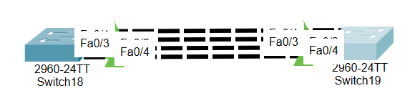

SW1

SW1(config)#

interface range fastEthernet 0/1 - 4

channel-group 2 mode desirable

exit

interface port-channel 2

switchport mode trunk

exit

SW2

SW1(config)#

interface range fastEthernet 0/1 - 4

channel-group 2 mode desirable

exit

interface port-channel 2

switchport mode trunk

exit

**FRAME RELAY WITH SUB INTERFACES.**



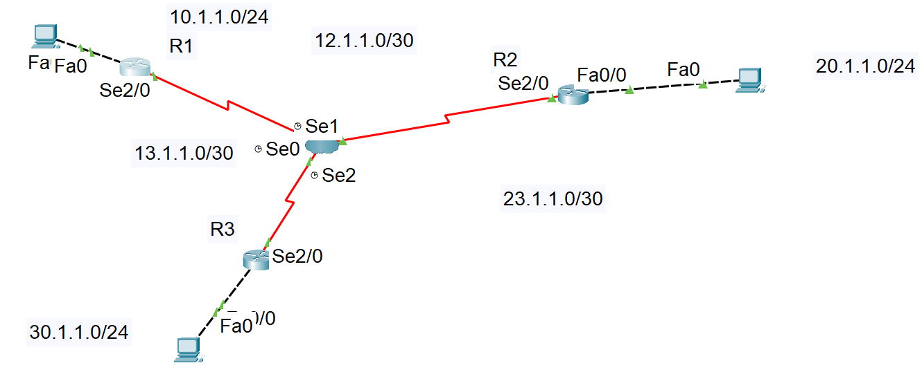

R1

interface fastEthernet 0/0

ip address 10.1.1.10 255.255.255.0

no shutdown

exi

hostname R1

R2

interface fastEthernet 0/0

ip address 20.1.1.10 255.255.255.0

no sh

exit

hostname R2

R3

interface fastEthernet 0/0

no shutdown

ip address 30.1.1.10 255.255.255.0

no shutdown

exit

hostname R3

R1

router eigrp 100

network 23.0.0.0

network 12.0.0.0

network 10.0.0.0

no auto-summary

exit

R2

router eigrp 100

network 12.0.0.0

network 20.0.0.0

no auto-summary

network 23.0.0.0

exit

R3

router eigrp 100

no auto-summary

network 23.0.0.0

network 13.0.0.0

network 30.0.0.0

exit

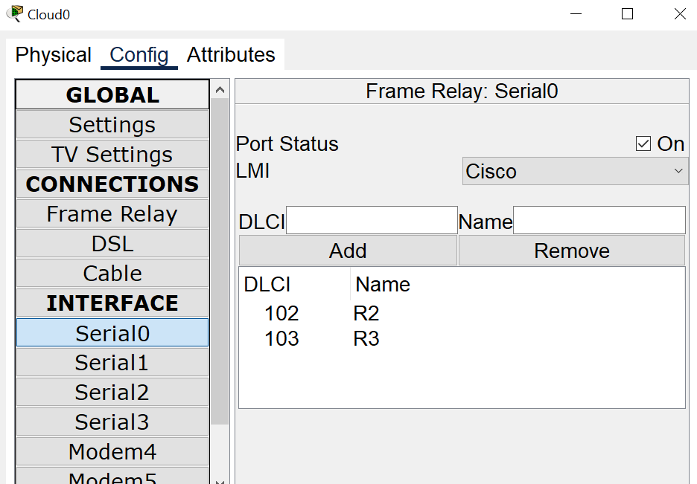

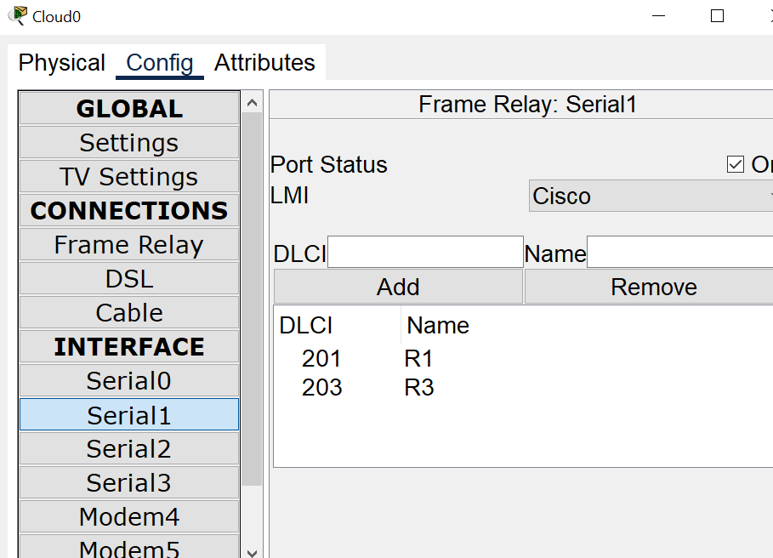

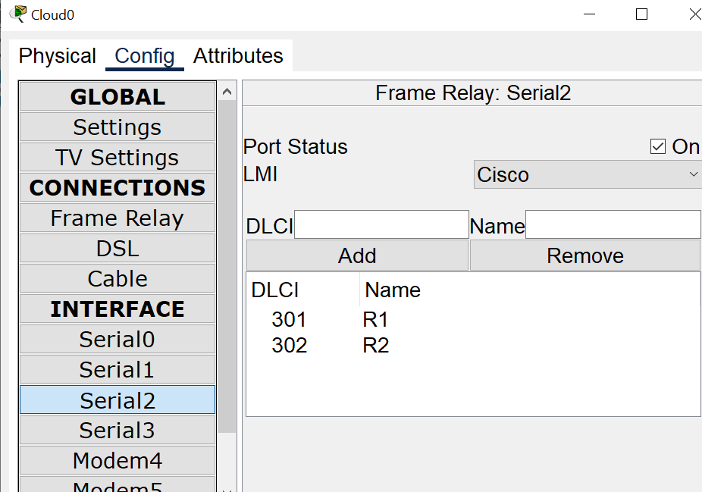

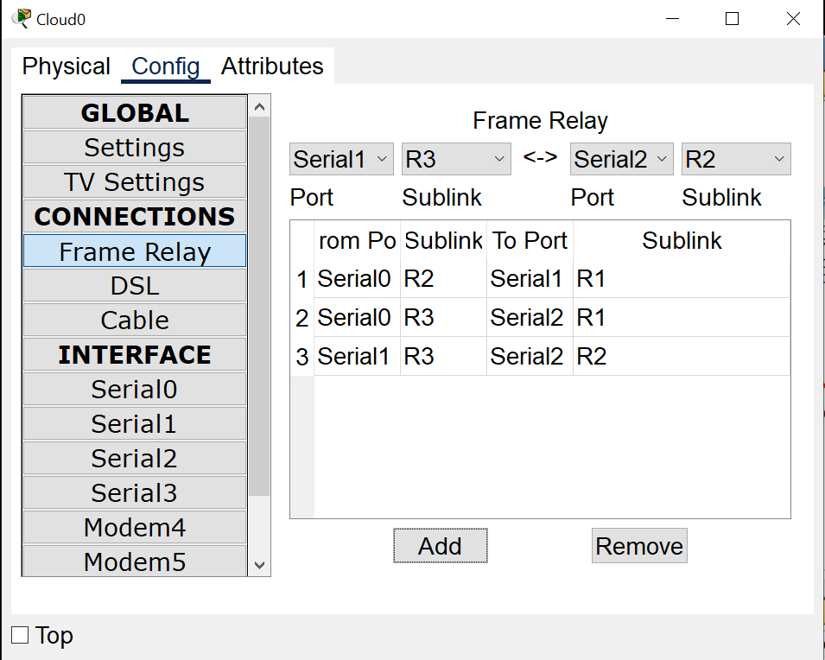

R1

interface serial 2/0

no ip address

no encapsulation frame-relay

exit

R2

interface serial 2/0

no ip address

no encapsulation frame-relay

exit

R3

interface serial 2/0

no ip address

no encapsulation frame-relay

exit

R3

interface serial 2/0

no shutdown

encapsulation frame-relay

exit

interface serial 2/0.301 point-to-point

ip address 13.1.1.2 255.255.255.252

bandwidth 64

frame-relay interface-dlci 301

exit

interface serial 2/0.302 point-to-point

ip address 23.1.1.1 255.255.255.252

bandwidth 64

frame-relay interface-dlci 302

exit

R2

interface serial 2/0

no shutdown

encapsulation frame-relay

exit

interface serial 2/0.201 point-to-point

ip address 12.1.1.2 255.255.255.252

bandwidth 64

frame-relay interface-dlci 201

exit

interface serial 2/0.203 point-to-point

ip address 23.1.1.2 255.255.255.252

bandwidth 64

frame-relay interface-dlci 203

exit

R1

interface serial 2/0

no shutdown

encapsulation frame-relay

exit

interface serial 2/0.102 point-to-point

ip address 12.1.1.1 255.255.255.252

bandwidth 64

frame-relay interface-dlci 102

exit

interface serial 2/0.103 point-to-point

ip address 13.1.1.1 255.255.255.252

bandwidth 64

frame-relay interface-dlci 103

exit